**f. 91r**

¶ca*pitulum* •79•

**f. 91v**

¶

**f. 92r**

**f. 92v**

• racio hic

ponit*ur* q*ua*re

sic plora*n*s clama*ui*t

¶

**f. 93r**

¶ca*pitulum* ~~7~~•80•

**f. 93v**

¶

**f. 94r**

**f. 94v**

¶ca*pitulum* •81•

**f. 95r**

**f. 95v**

¶

**f. 96r**

langyng loue]

[ca*pitulum* •82•

**f. 96v**

no*ta*

feruor of loue

¶

¶

(•••

neyþ*yr* wepyn

**f. 97r**

n*ota*

¶ca*pitulum* •83•

~~i a~~ i 1

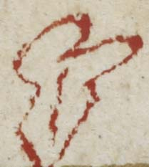

**f. 97v**

¶

0------

**f. 98r**

n*ota*

¶ca*pitulum* •84•

~~i b~~ i ii

¶

**f. 98v**

d

¶ no*ta* *b*e*n*e

**f. 99r**

n*ota*

n*ota*

no*ta* b*e*n*e*

i iii

¶

mark

**f. 99v**

¶no*ta b*e*n*e

¶

no*ta*

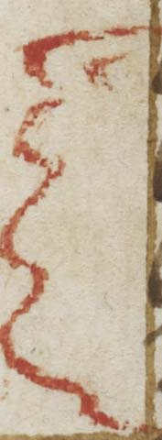

**f. 100r**

n*ota*

no*ta* b*e*n*e*

¶ca*pitulum* •85•

i iiii 100

any •

¶

**f. 100v**

no*ta* b*e*n*e*

¶

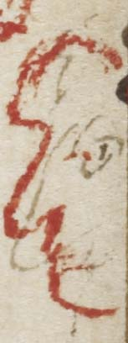

**f. 101r**

n*ota*

n*ota*

n*ota*

i v

**f. 101v**

n*ota*

¶ca*pitulum* •86•

O

¶

**f. 102r**

i vi

**f. 102v**

¶

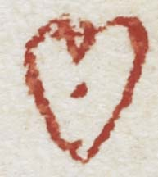

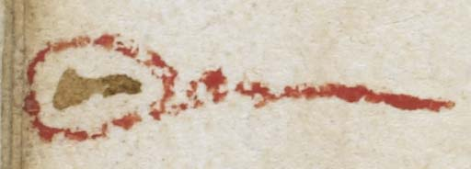

**f. 103r**

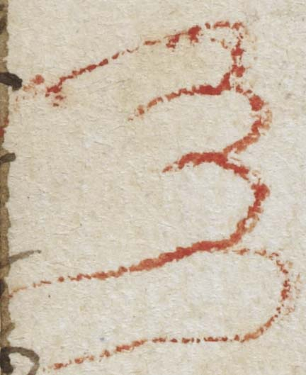

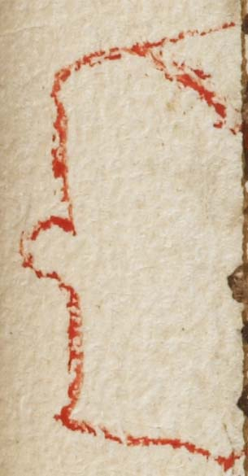

**f. 103v**

¶ca*pitulum* •87•

**f. 104r**

no*ta* b*e*n*e*

n*ota* o*wr* lade

**f. 104v**

¶

¶

¶ca*pitulum* •88•

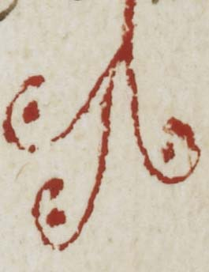

**f. 105r**

no*ta* b*e*n*e*

me*n*tall p*ra*er •

n*ota*

]

¶

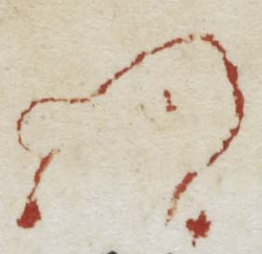

**f. 105v**

¶

•:-------